Twine Lesson - A simple story

Author: Chris Kerslake (chris@xmodus.com)
2022-11-20

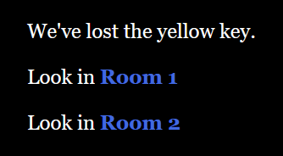
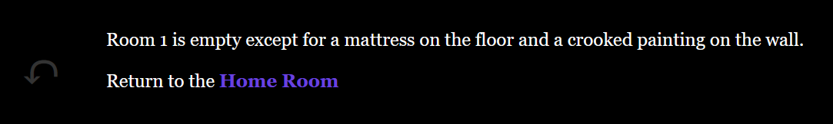

Copyright:
This work is licensed under a Creative Commons Attribution-NonCommercial-ShareAlike 4.0 International License.

Contents
Creating a simple story using Twine 3
Step: Planning 3
Step: Create a new story 3
Step: Rename the passage 4
Step: Fill in the Home Room text. 5
Step: Add Room 1. 5
Step: Fill in the text for Room 1 6
Step: Testing a passage: Test From Here 7
Step: Testing a passage: Start Story Here 7
Step: Reset the starting page back to Home Room 8
Step: Add Room 2 from the Home Room 8
Step: Add text to Room 2’s passage 8
Step: Add a return link to Room 1 9
Step: Play test your story 9
Step: Publish your story 10
Step: Importing a story 10
Beyond the Simple Story 13
Proofing your work. 13
A Few Passage Toolbar Items 13
Styles (BIS) 13
Tags 14
Colour Wheel 15
A few gotcha 17
How to Recover an Accidentally Deleted Passage 17
Twine Appears to Break After Importing Project 17
Misspelling Passage Names & Orphan Passages 18

Creating a simple story using Twine
The following is a step-by-step guide to building a simple story using Twine (screenshot are for Twine v. 2.5.1). This simple story will be composed the following:
- A Home Room and two other rooms (Room 1 and Room 2).
- The goal is to find the yellow key.
- The key is in Room 2.
- The story ends when we find the yellow key.

Step: Planning
Before we start using Twine, we should plan out what our story will look like. This is a simple story, so it will have a simple plan. We will start with a ‘Home Room’ that will provide some background to our story and then link to two branches in our story. We will then fill in the two branches but link them back to the Home Room. Room 2 will contain the yellow key.
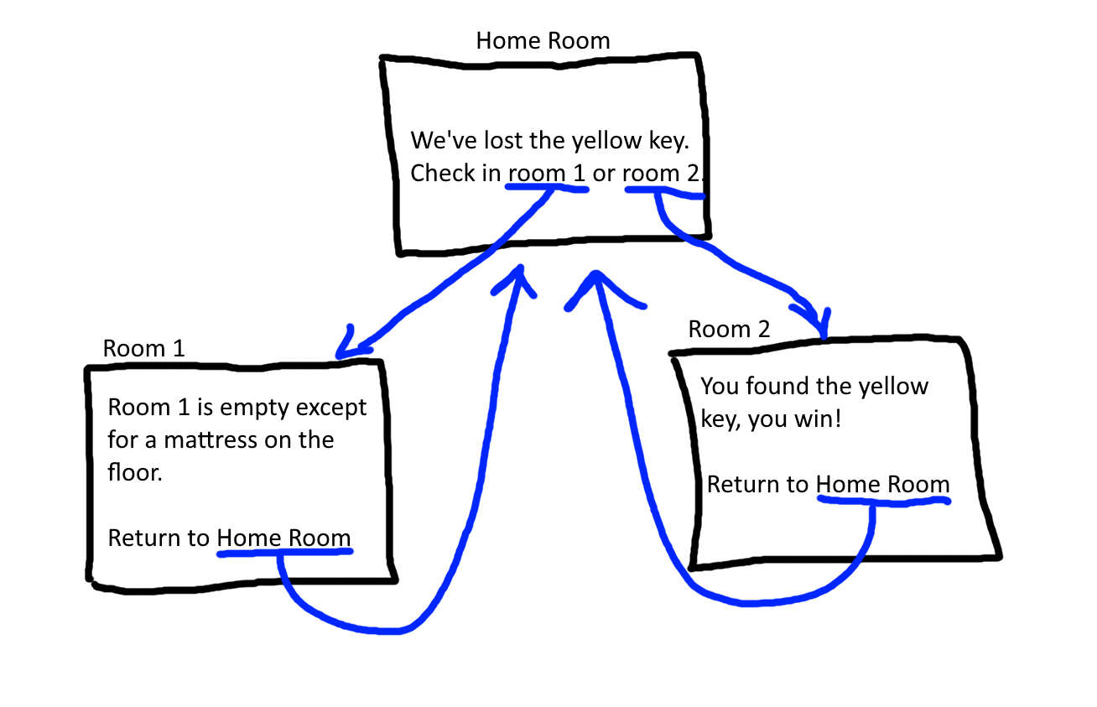

Step: Create a new story
Create a new story named “A simple story”.
Click on Story > “+ New”
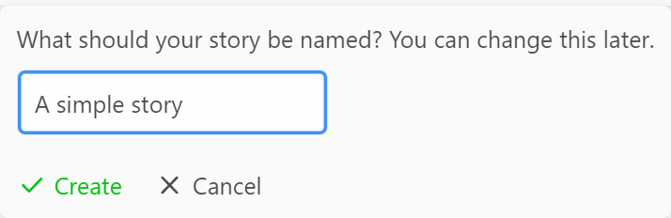
Click the green “Create” to create the new story.

We will get a new story with a single passage (titled “Untitled Passage” and a green rocket icon attached to it).
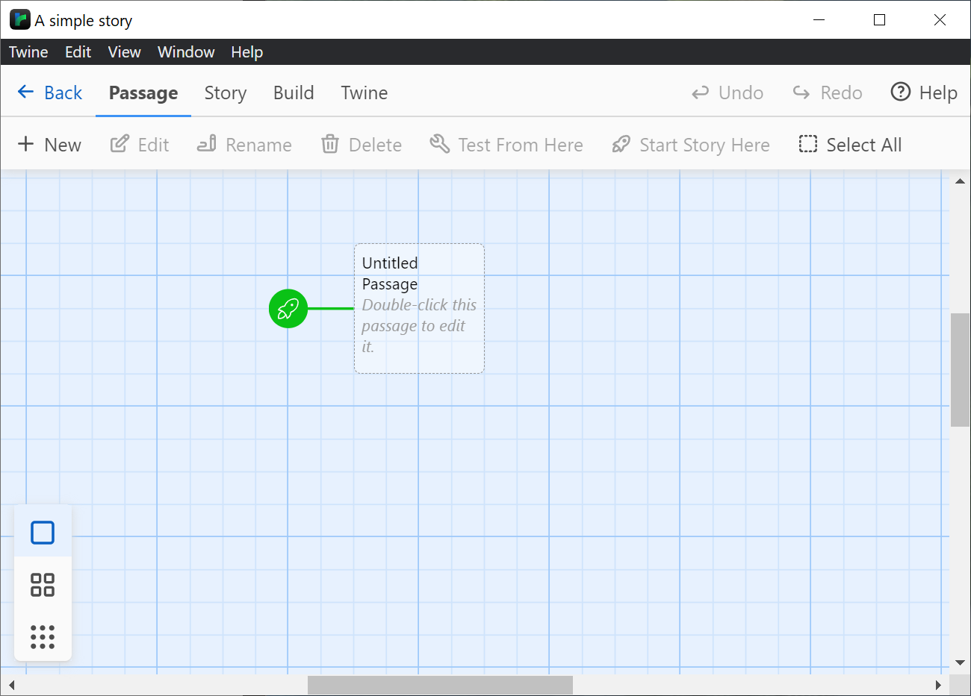

Step: Rename the passage
Double click on the “Untitled Passage” to open the Passage popup window.
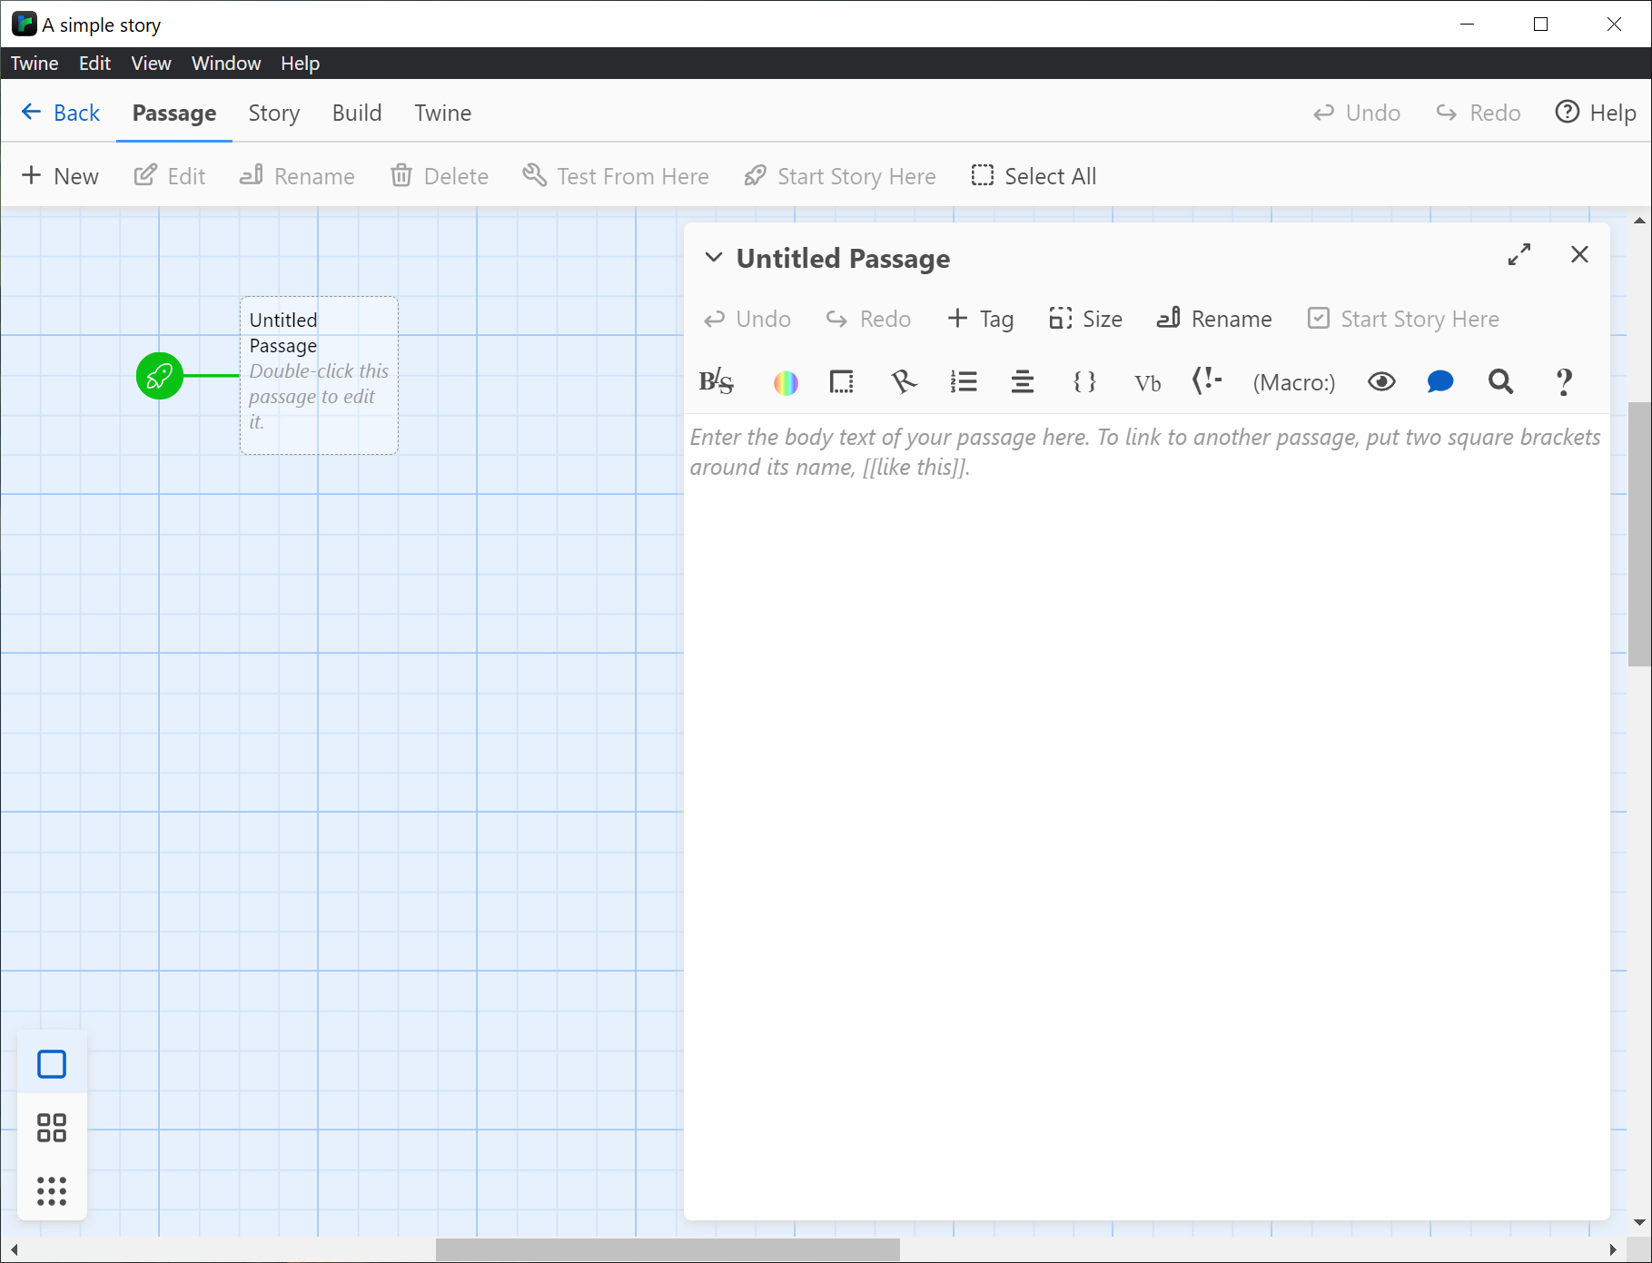
Now, click on the “Rename” link to open the rename popup.
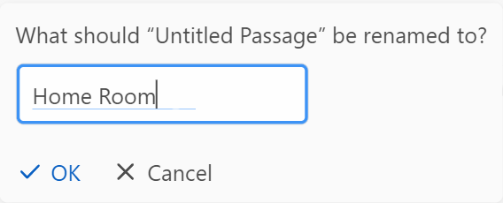
Fill in the new name and click the “OK” button.
Notice that the title changed both on the top of the passage popup and also on the story board area to the left.

Step: Fill in the Home Room text.
Now that we have our “Home Room” passage open, let’s fill in our story for this passage.
We’ve lost the yellow key.
Look in Room 1
Look in Room 2

Now that we have our first passage, let’s “Play” our story. To do this, click on Build > Play. This should open a browser window with your first passage.
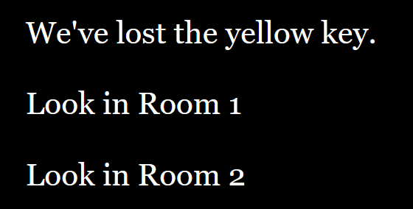
This version of the story doesn’t branch or do anything, it’s just the text. The rooms aren’t links.

Step: Add Room 1.
Now that we have our Home Room, let’s add Room 1. You could click on Passage > “+ New” to add a new passage, but instead let’s let Twine do that for us. Return to your Home Room passage and add double-square brackets (beside the letter ‘p’ on your keyboard) around the text “Room 1”, like this:
[[Room 1]]

Twine will automatically add a new passage titled, “Room 1”:
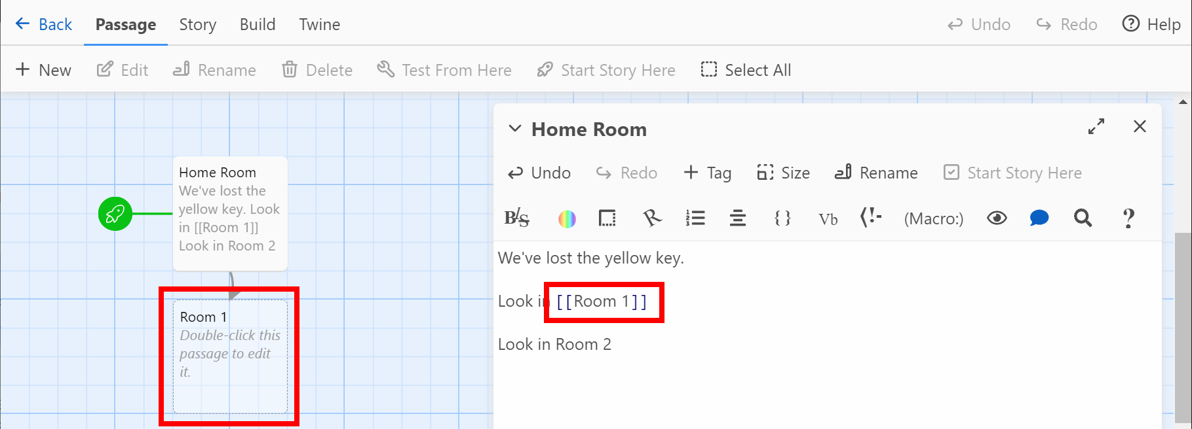
Double click on the new Room 1 passage on the story board to open it up.
If you play your story (Build > Play), your Home Page will now have a link for Room 1.
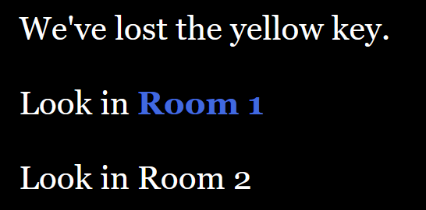
And, if you click on the “Room 1” link, it will take you to a blank Room 1 passage.
Note that the gray arrow on the left of the blank page is the “Undo” arrow. Clicking it will return to the previous page. So, click it to return to the Home Page.

Step: Fill in the text for Room 1
Fill in a single sentence description of the room (or more if you want). I chose the following:
Room 1 is empty except for a mattress on the floor and a crooked painting on the wall.
After you fill in your Room 1 text, click the Build > Play button again and return to Room 1.
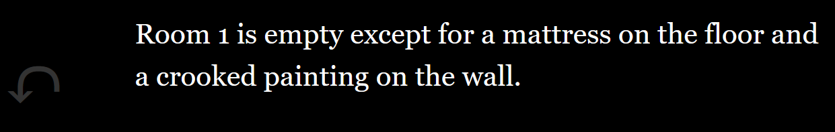

Now, before we start on Room 2, notice that as your story grows, you won’t want to have to navigate back to each page starting from your home page. So, instead, you have two main options: just test the currently selected passage or change the starting page for the story to this passage. On the Passage toolbar there are two options for each passage: “Test From Here” and “Start Story Here”.
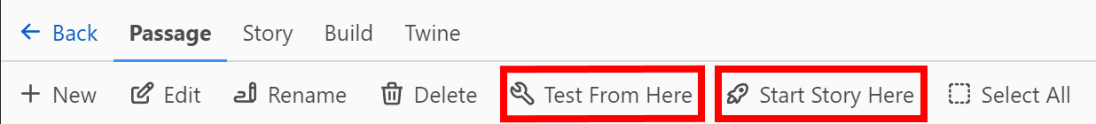

Step: Testing a passage: Test From Here
When editing a passage, you may want to preview it as-is. To do that, click on Passage > Test From Here to launch your browser and show the currently selected passage.

Step: Testing a passage: Start Story Here
To change the passage where the story starts, click on the passage you want to start from, Room 1 in this example, on the story board, so that it is selected (blue), as shown here:
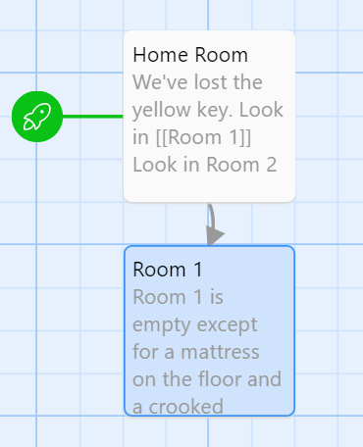

Next, click on the “Passage” menu option for Twine and when you click the “Start Story Here”, the little green rocket ship will change to point to the current passage (in this case “Room 1” instead of “Home Room”).
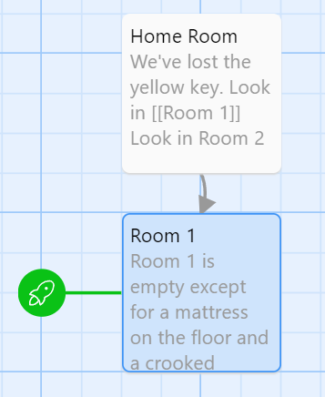
Now if we click Build > Play, instead of starting at our Home Room, we will start at Room 1.

Step: Reset the starting page back to Home Room
Before continuing, let’s reset the starting page back to the Home Room by clicking on Home Room on the story board and then under Passage, click “Start Story Here”. The little green rocket ship should now be point to Home Room again.
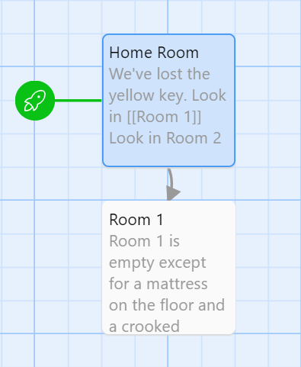

Step: Add Room 2 from the Home Room
Double click on the Home Room passage and just like for Room 1, add double square brackets around the Room 2 text to both create a new Room 2 passage and link to it.
[[Room 2]]
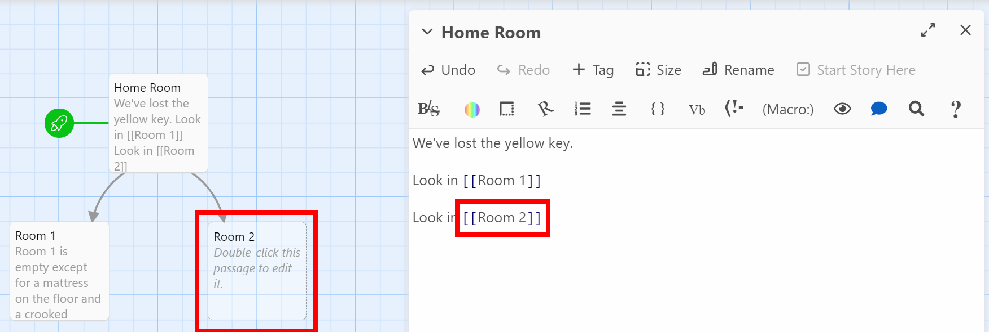

Step: Add text to Room 2’s passage
Now that you have your new Room 2 passage, double-click on it to open it so we can add text to it.
You found the yellow key. You win!
Return to the [[Home Room]]

Note that once you add the text, including the link back to the Home Room, the line connecting the Home Room and Room 2 passages will show arrows in both directions.
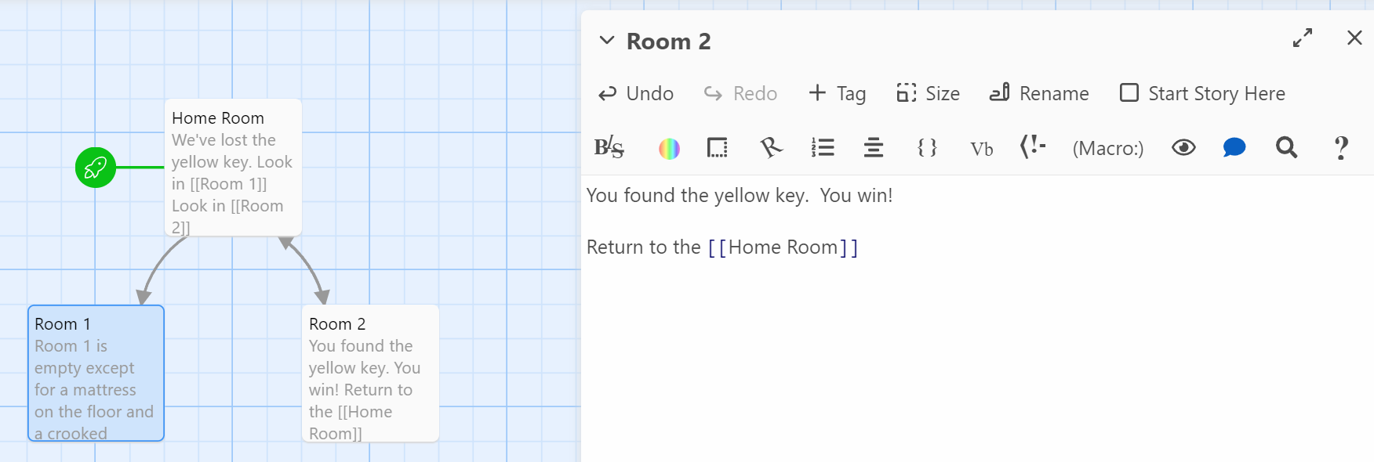

Step: Add a return link to Room 1
For completeness, we should the return link to Room 1 as well:
Return to the [[Home Room]]

Step: Play test your story
Now that we have our simple story created, we should test it. To do this, click on Build > Play to launch your story.

Step: Publish your story
Now that our simple story is complete, we should publish it to an HTML file. Click Build > Publish to File.
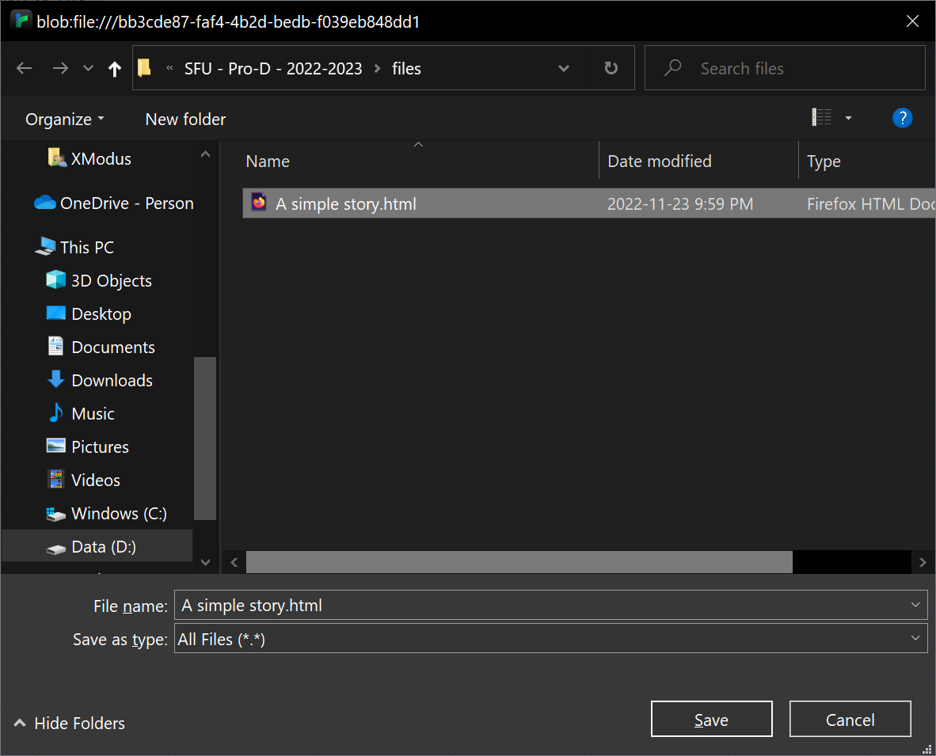
Once you click the Save button, a single HTML file will be created. Double-clicking on this HTML file will open your Twine story. This is what students will submit for assessment, to take a copy home, or to share with their classmates.

Step: Importing a story
A published Twine story is a self-contained copy of the entire story and all of its elements. As a result, you can import a Twine story into Twine to review or edit it. To do this, click Library > Import and a little import pop-up will appear in the bottom-right corner of the Twine screen:
Click the Browse button and locate the .html file that you wish to import.
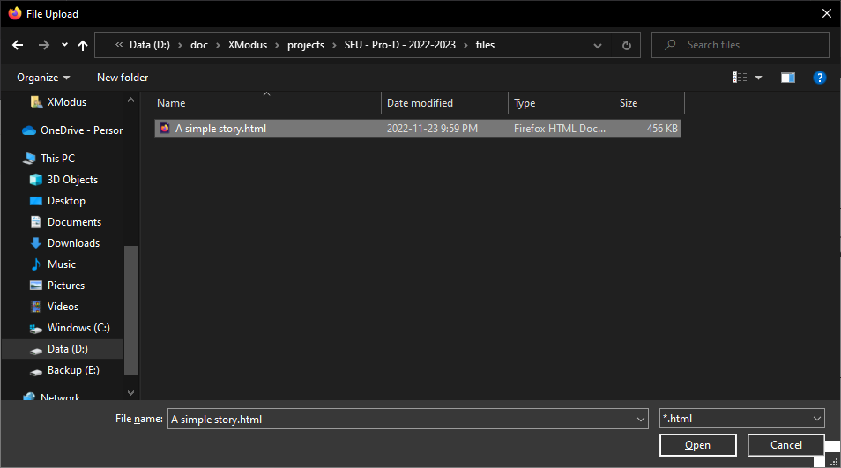
Click the “Open” button to return to Twine. Twine will then show you all of the stories that it found. In this example, there is a single story titled “A simple story” in the .html file “A simple story.html”.
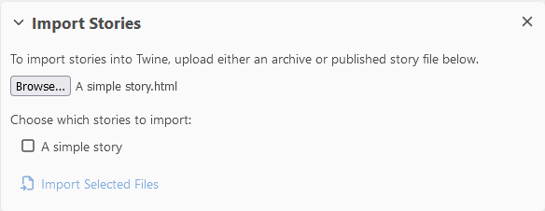

You must check the checkbox to the left of the story and then click the “Import Selected Files”.
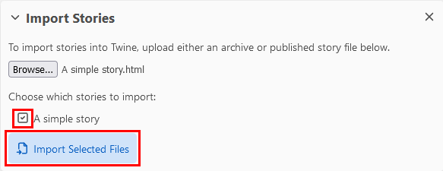
After you import the file, it should appear in your list of stories.
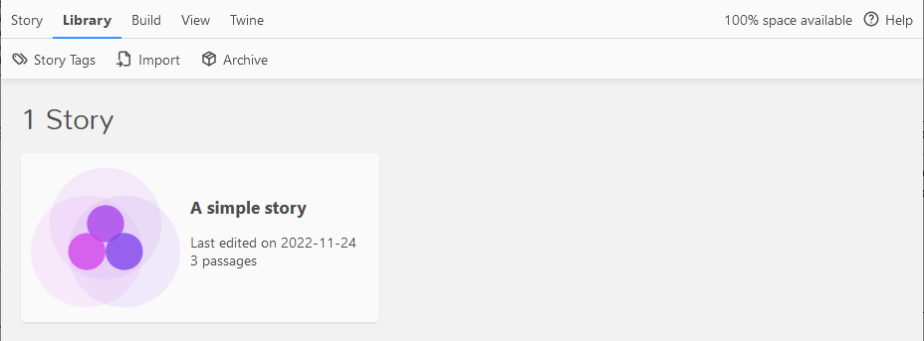

Beyond the Simple Story
Now that we’ve created a simple story, let’s look at some other features in Twine.

Proofing your work.
As the number of passages grows, it can be challenging to keep track of all of the passages and their text. You can generate a proofing view of your story within Twine via Build > Proof. The results will look like this:
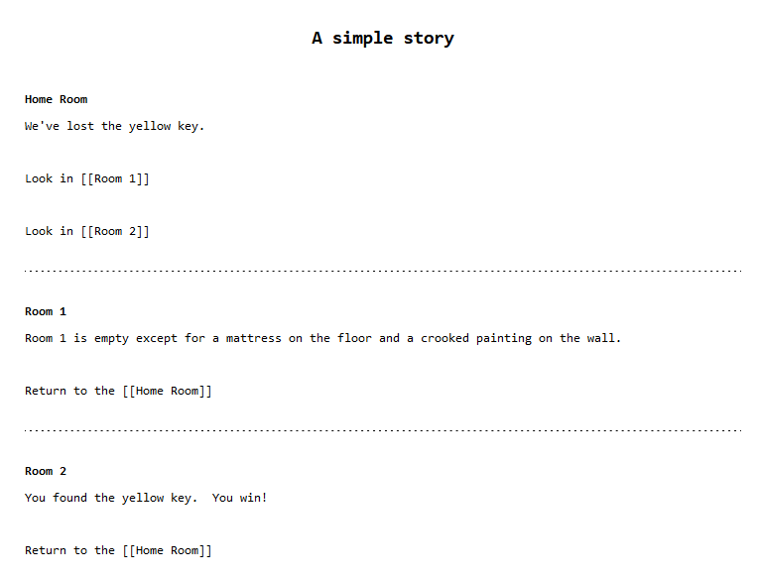

A Few Passage Toolbar Items
When editing a passage, there is a toolbar above the passage that contains a number of useful tools. Here are a couple of them.
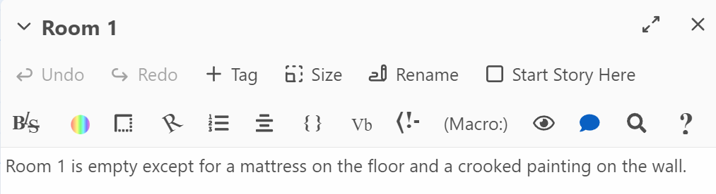

Styles (BIS)
The BIS icon is where you will find the Styles options. Start by selecting some text on your page and then clicking the Styles icon to bring up a pop-up window with style options:
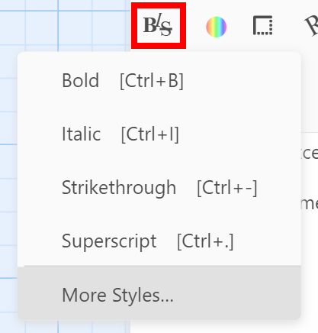

Tags
The “+ Tag” button allow you to add tags to your passages. Think of tags as categories or attributes you can add to organize your stories.
For example, I could create a “game-over” tag and then tag all of the passages where the game ends.
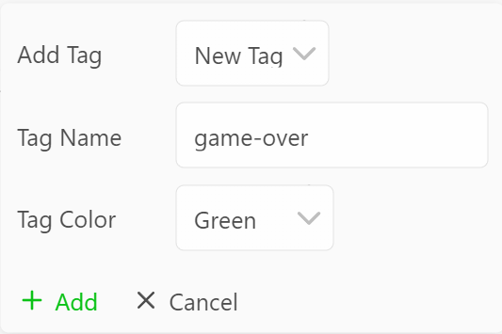
This will add the tag to the top of the passage and also add the color to the top of the passage in the story board area.
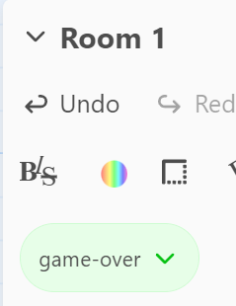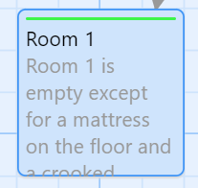

Tags can be used later in combination with CSS (Cascading Style Sheets) to change the color or style of the page based on the tags. For example, to change the background color of any of the “game-over” tagged passages, you could add the following to the CSS.
[tags="game-over"] {
background: "green";
}

Colour Wheel
There is a color wheel icon on the toolbar that allows you to change the color of individual words or groups of words in the passage. To start, select the word(s) and then click the Colours icon. For example, let’s change the text “yellow key” to yellow.
Select the text:
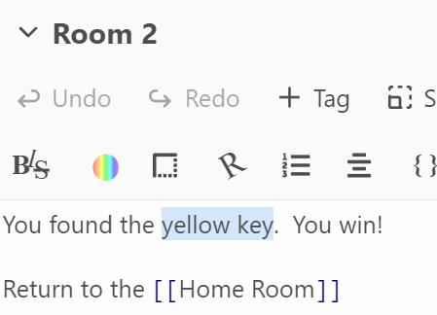

Then click the Colours icon. A pop-up will appear with the text “Example text preview” at the top. To change just the text colour, I clicked on the “Flat colour” option under “Text colour” and then selected yellow. As a result, the sample text changed colour to yellow. Then clicked the “Add” button at the bottom-right to change the text colour.
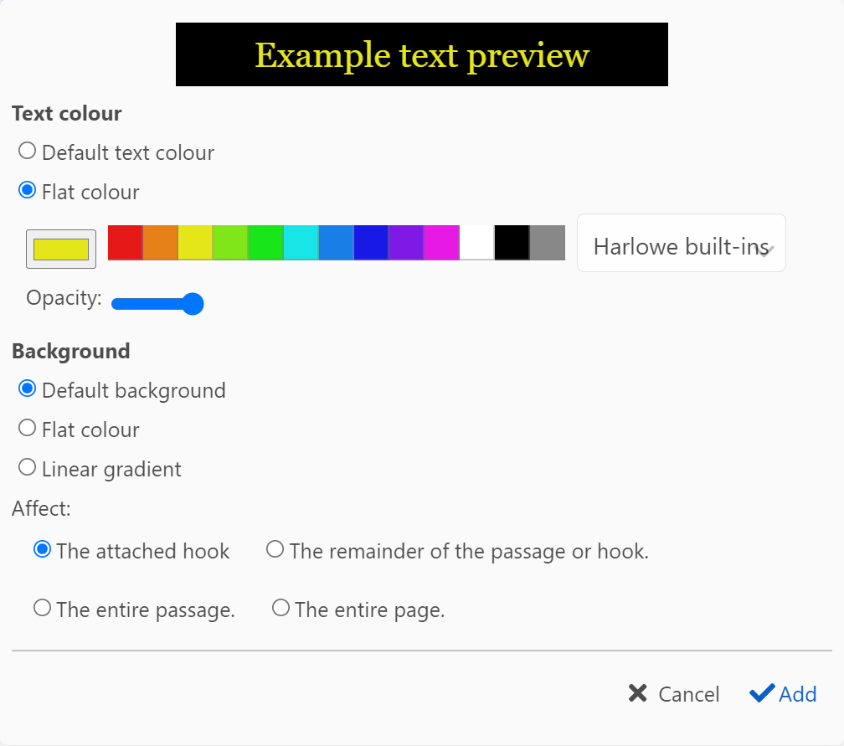
Note that in the passage, the text “yellow key” is now surrounded by single double-brackets and in front of the text is the text (text-colour:yellow). The text on the right, in square brackets is called a hook and the text inside the parentheses on the left is called a macro. This text-colour macro changes the text colour for the text inside the hook. Note that at the bottom of the pop-up window, you can see that the “Affect” section states that the change is for “The attached hook”. You can change the affected area by changing these values.
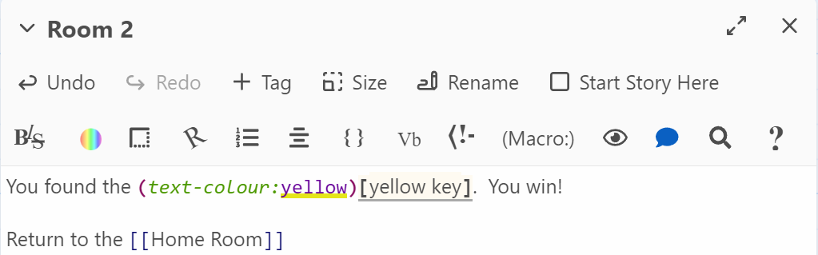

A few gotcha
Below are a few situations in Twine to be aware of.

How to Recover an Accidentally Deleted Passage
You or someone in your class will accidentally delete a passage by clicking the “Delete” key while reviewing a passage. I know because it happened to me and like most people, I pressed CTRL+Z (Command+Z) to undo and nothing happened. I tried Edit > Undo and nothing happened. I tried re-creating a passage, but nothing happened. After looking around, I found the “Undo Passage Delete” link in the top-right corner of Twine. Clicking that restored my Room 1 passage.
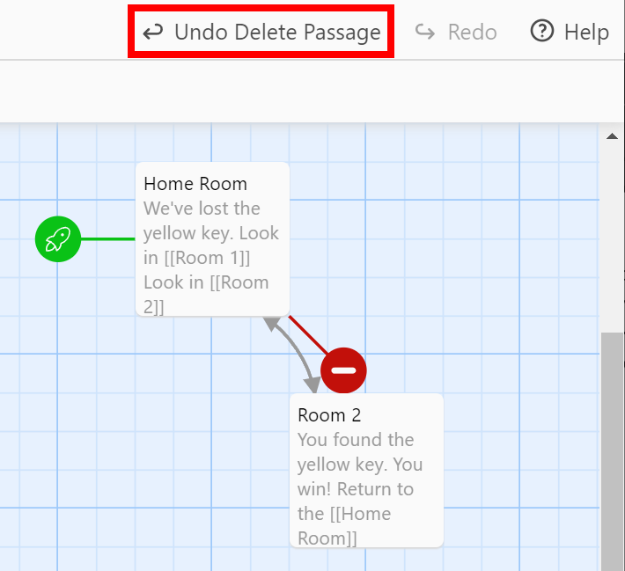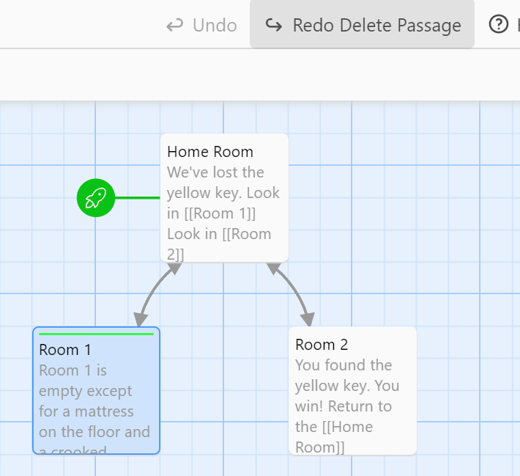

Twine Appears to Break After Importing Project
When importing Twine projects into Twine, especially with the desktop app, it is not uncommon to see an error page like this:
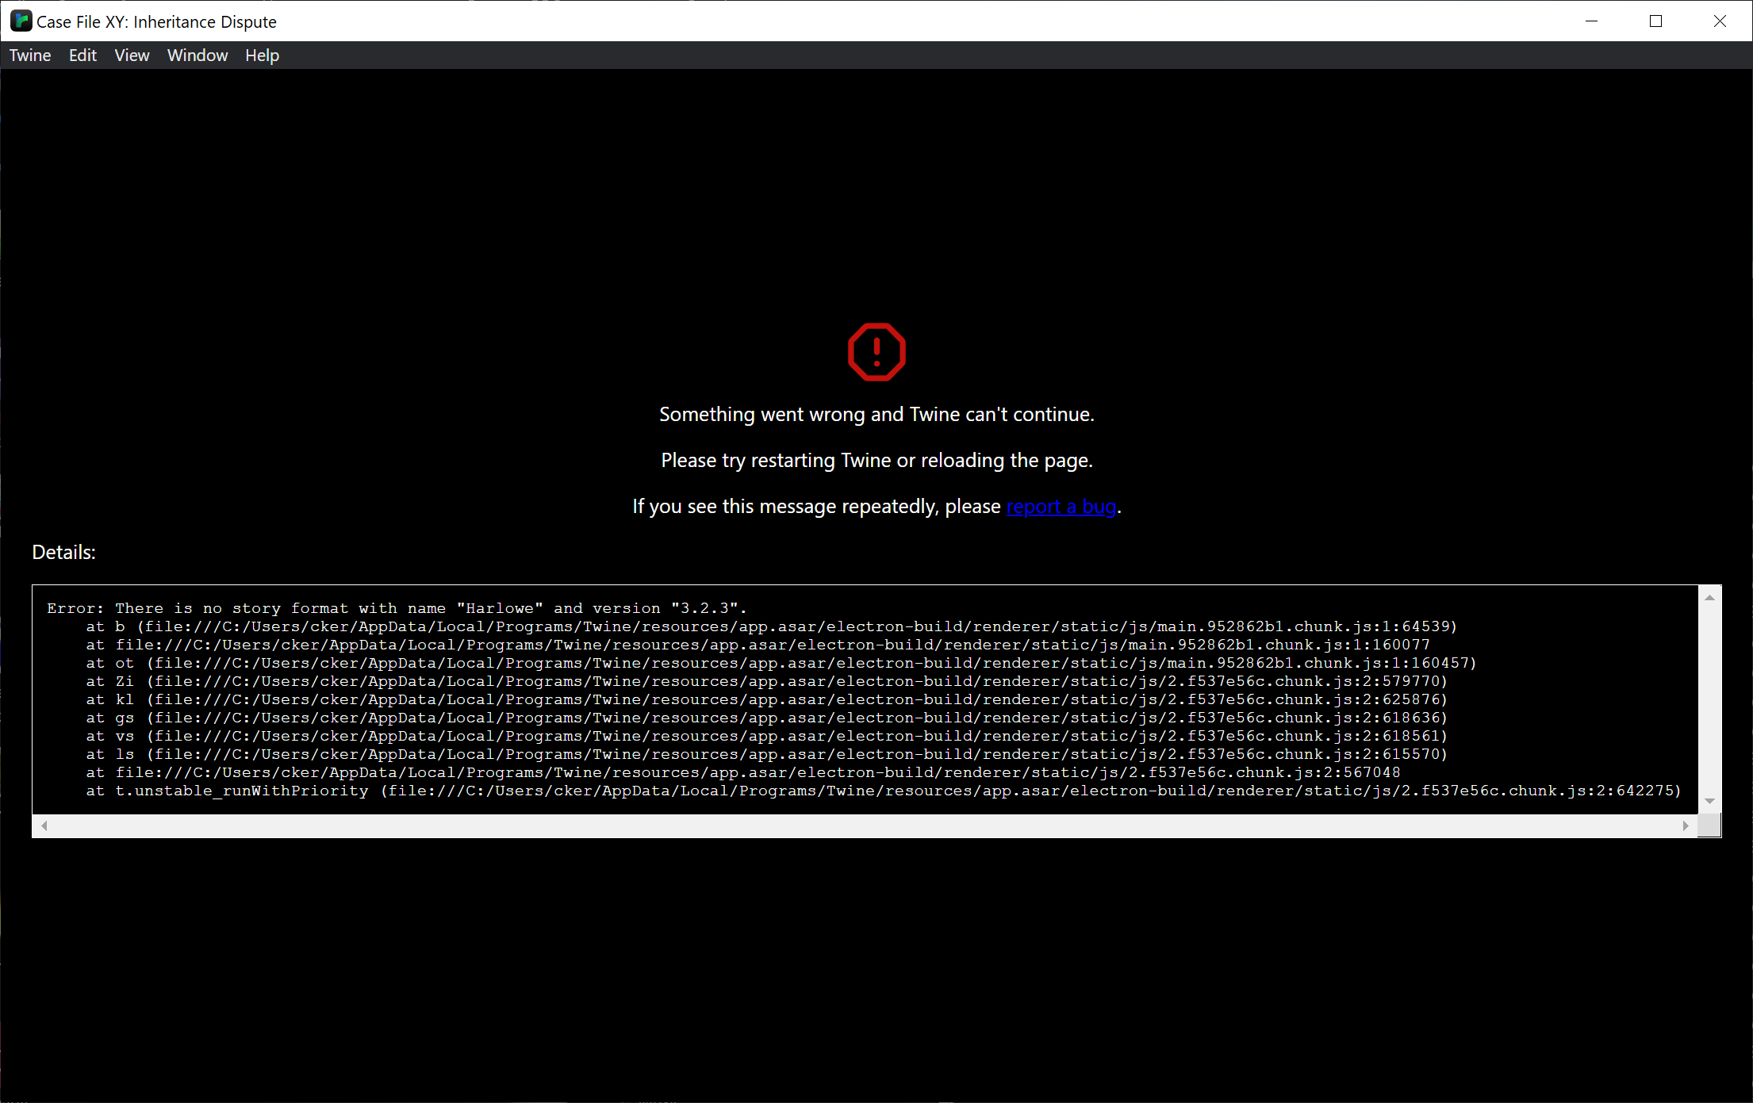
The solution most of the time is just to close and restart Twine and then re-open the file. I don’t know why Twine does this, but it is disconcerting the first time.

Misspelling Passage Names & Orphan Passages
As you become more proficient with Twine, it is not uncommon to just input passage names using the double square brackets directly. However, you must ensure that you match the case exactly or Twine will create a new passage. For example, if you type “room 1” instead of “Room 1”, Twine will create a new passage named “room 1” instead of linking to your “Room 1” passage. Also, once you correct the mistake, the incorrect “room 1” won’t automatically be deleted.
This appears to have been fixed in Twine 2.5. However, be aware that Twine is case-sensitive, so if you do create a “room 1” and another “Room 1”, that Twine will see those as two different passages.

